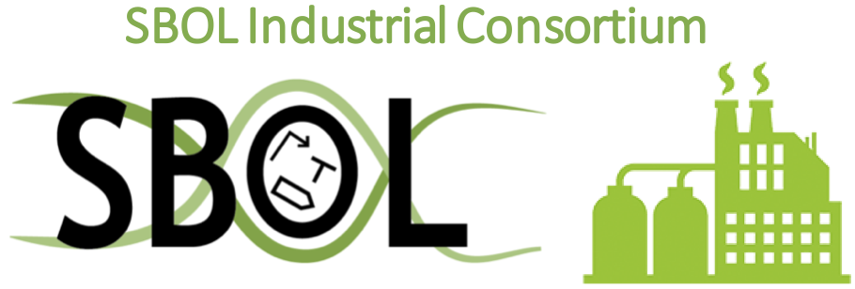
Call for Proposals:
SBOL Community Critical Infrastructure Support

The SBOL Industrial Consortium offers small-scale financial support for the maintenance of critical community infrastructure. This offer is for services or equipment only, not for labor. Examples include web hosting, domain registry, and cloud services.

Proposals are reviewed and accepted on a rolling basis.

Proposals should provide the following information:

Proposer:
Name:
Institution:
Address:
Email:
Phone:

Funding information:
Amount of funds requested:
Period of support requested (up to 1 year):
Basis of estimate (e.g., a quote matching funds requested):

Project description:
What will the requested funding support?
Why is this critical for the SBOL community?
How will success of this support be measured?

